Assignment#5 Akhil Suryadevara

A20391322

This is how our homepage would look like upon completion

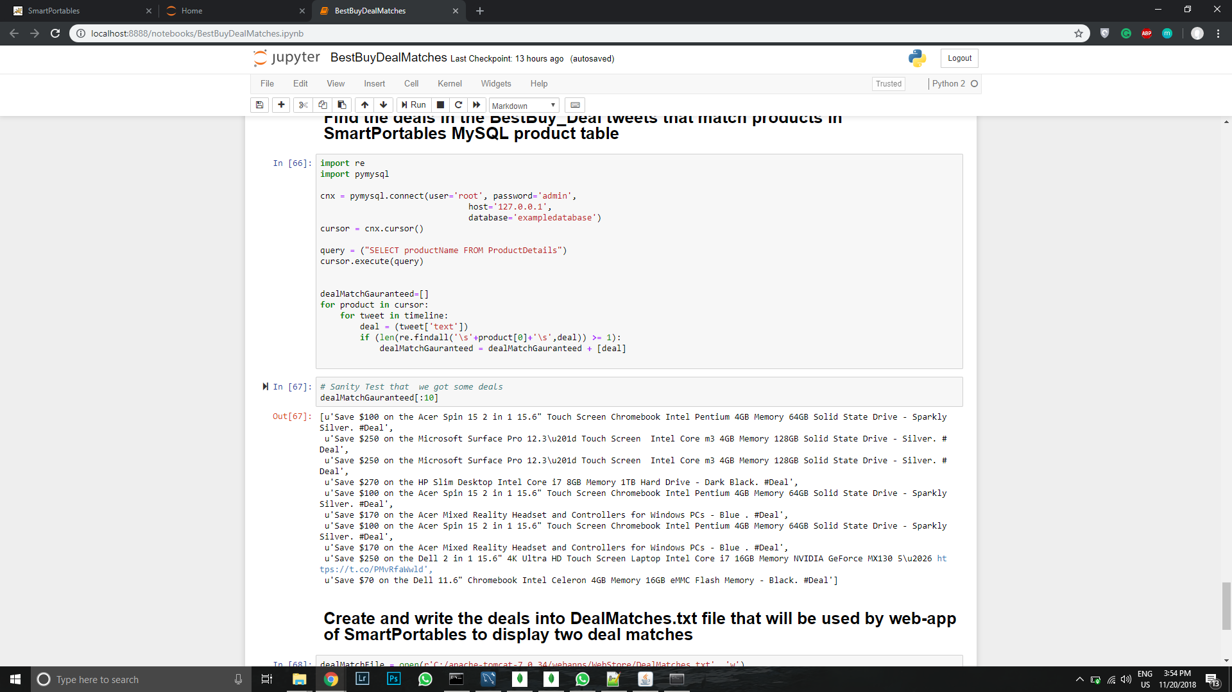

Upon execution of the given python script we would get the tweets

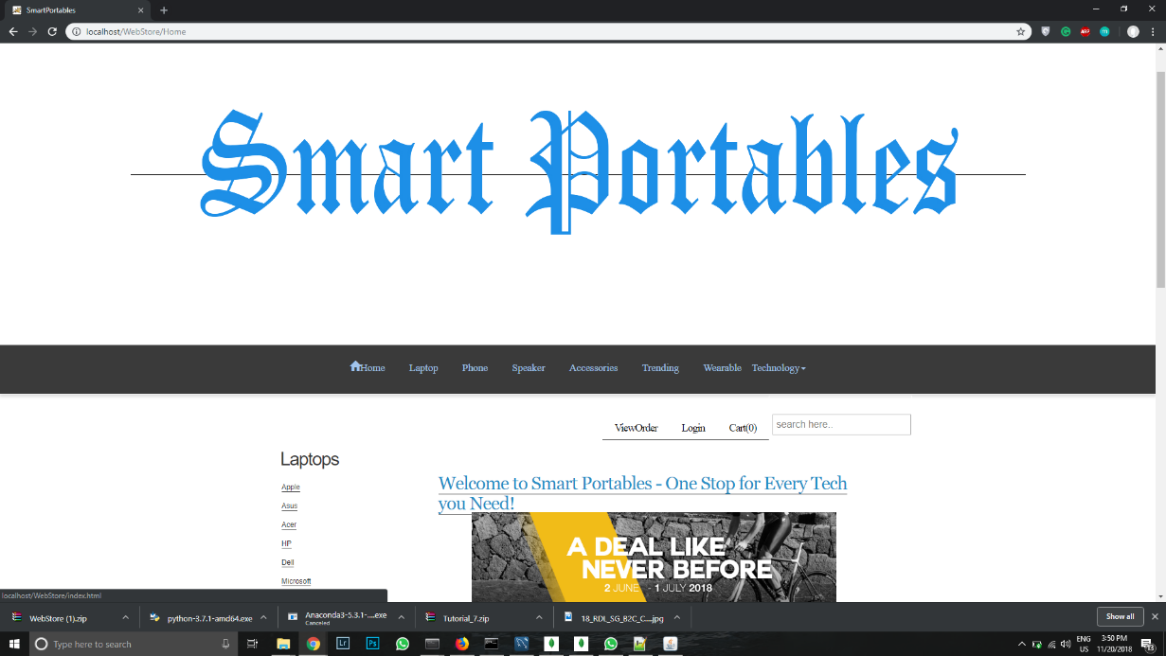

We could see them in the output file

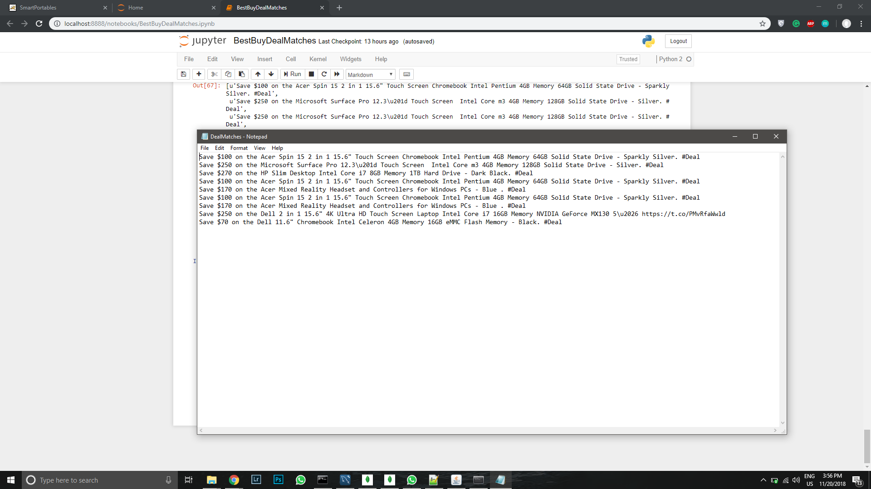

We could see the first 2 best deals here

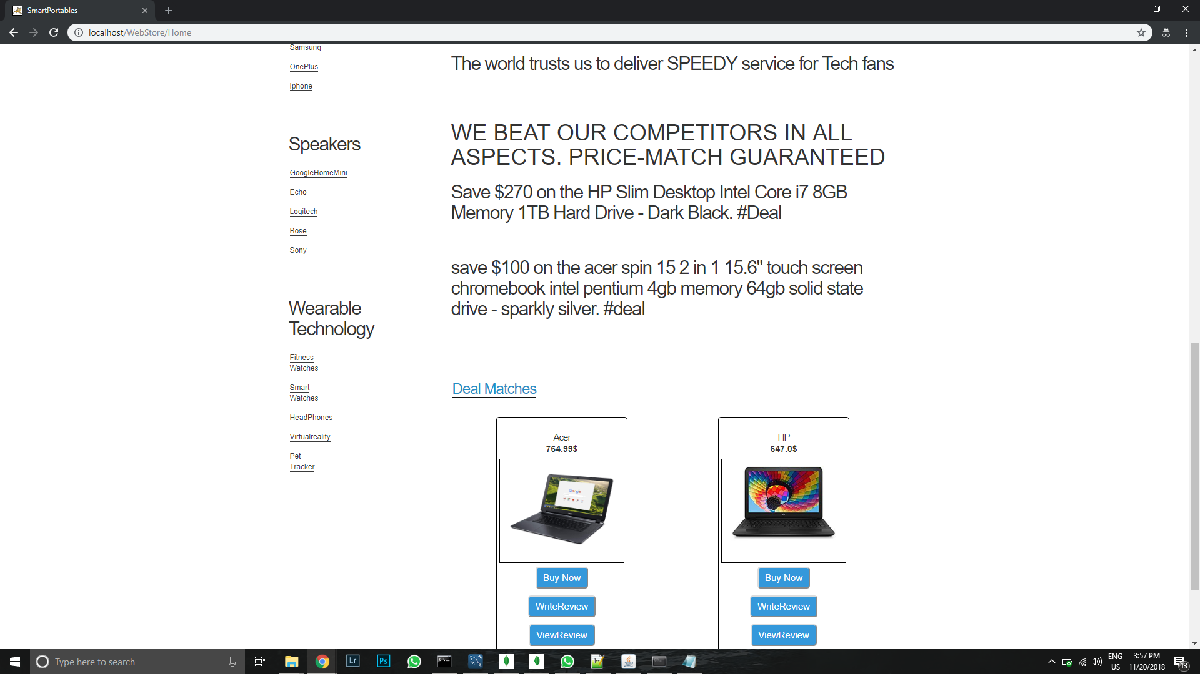

Later upon recommending the “Product Recommender” python script.

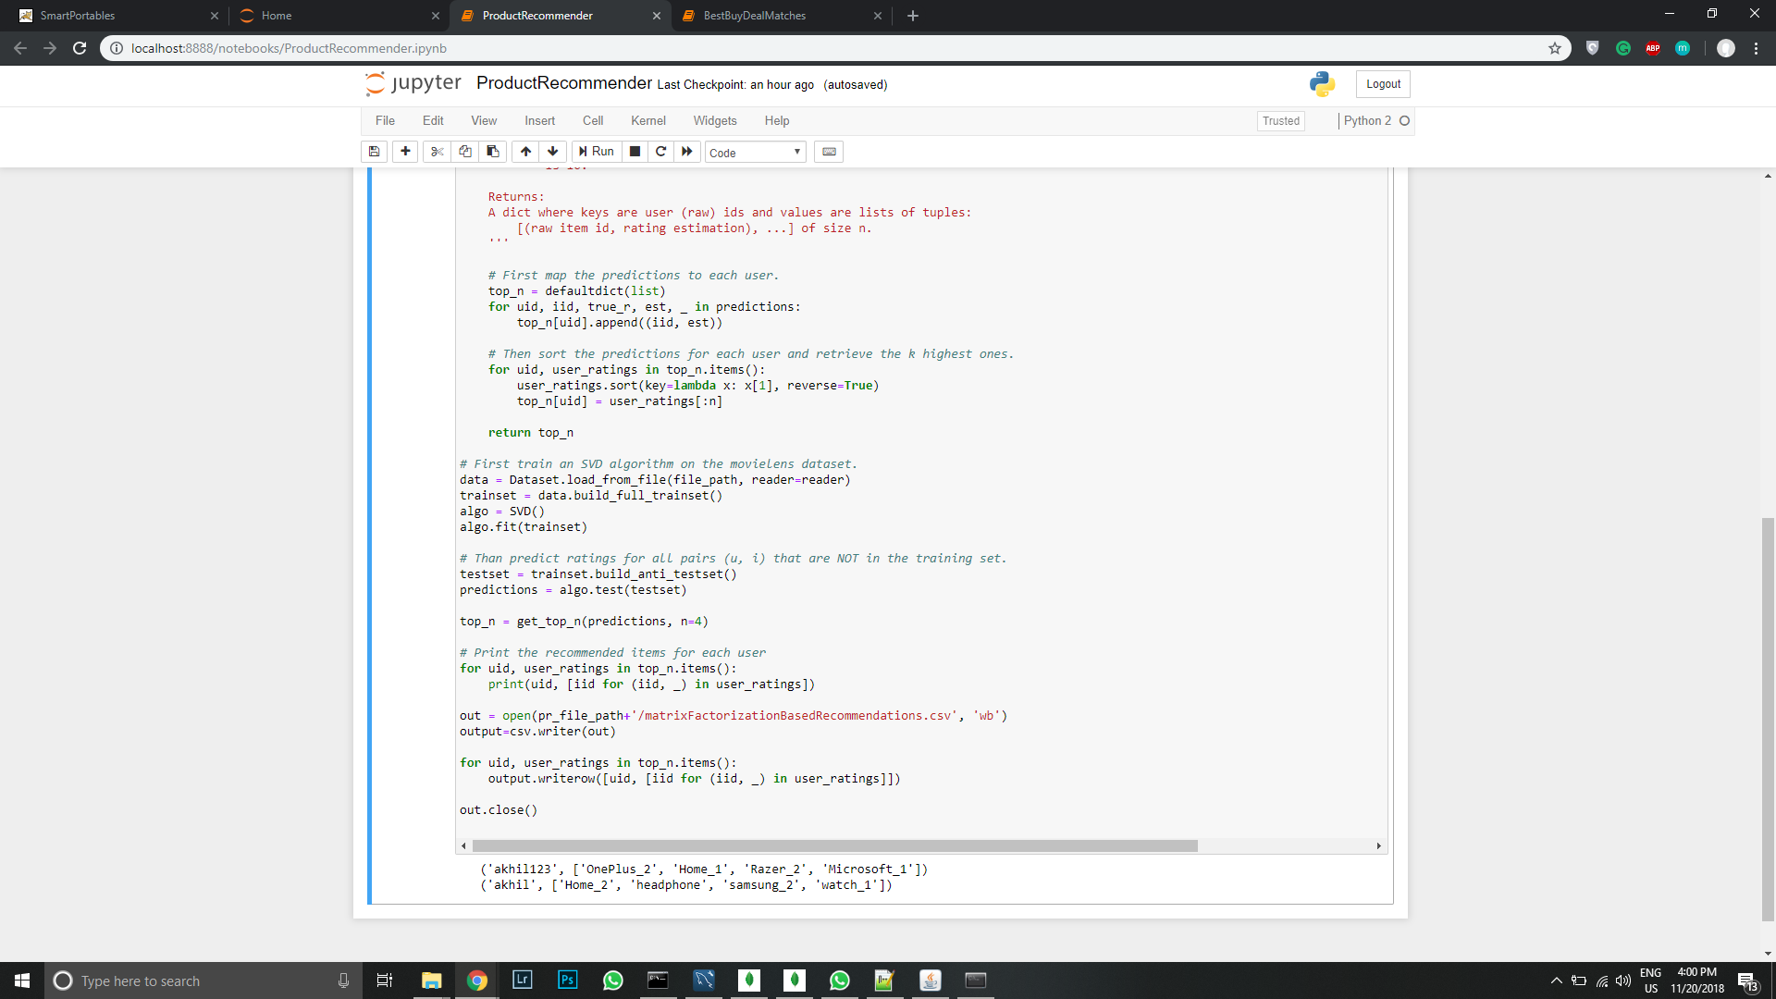

We would get the recommendations and can see them in the output files too. 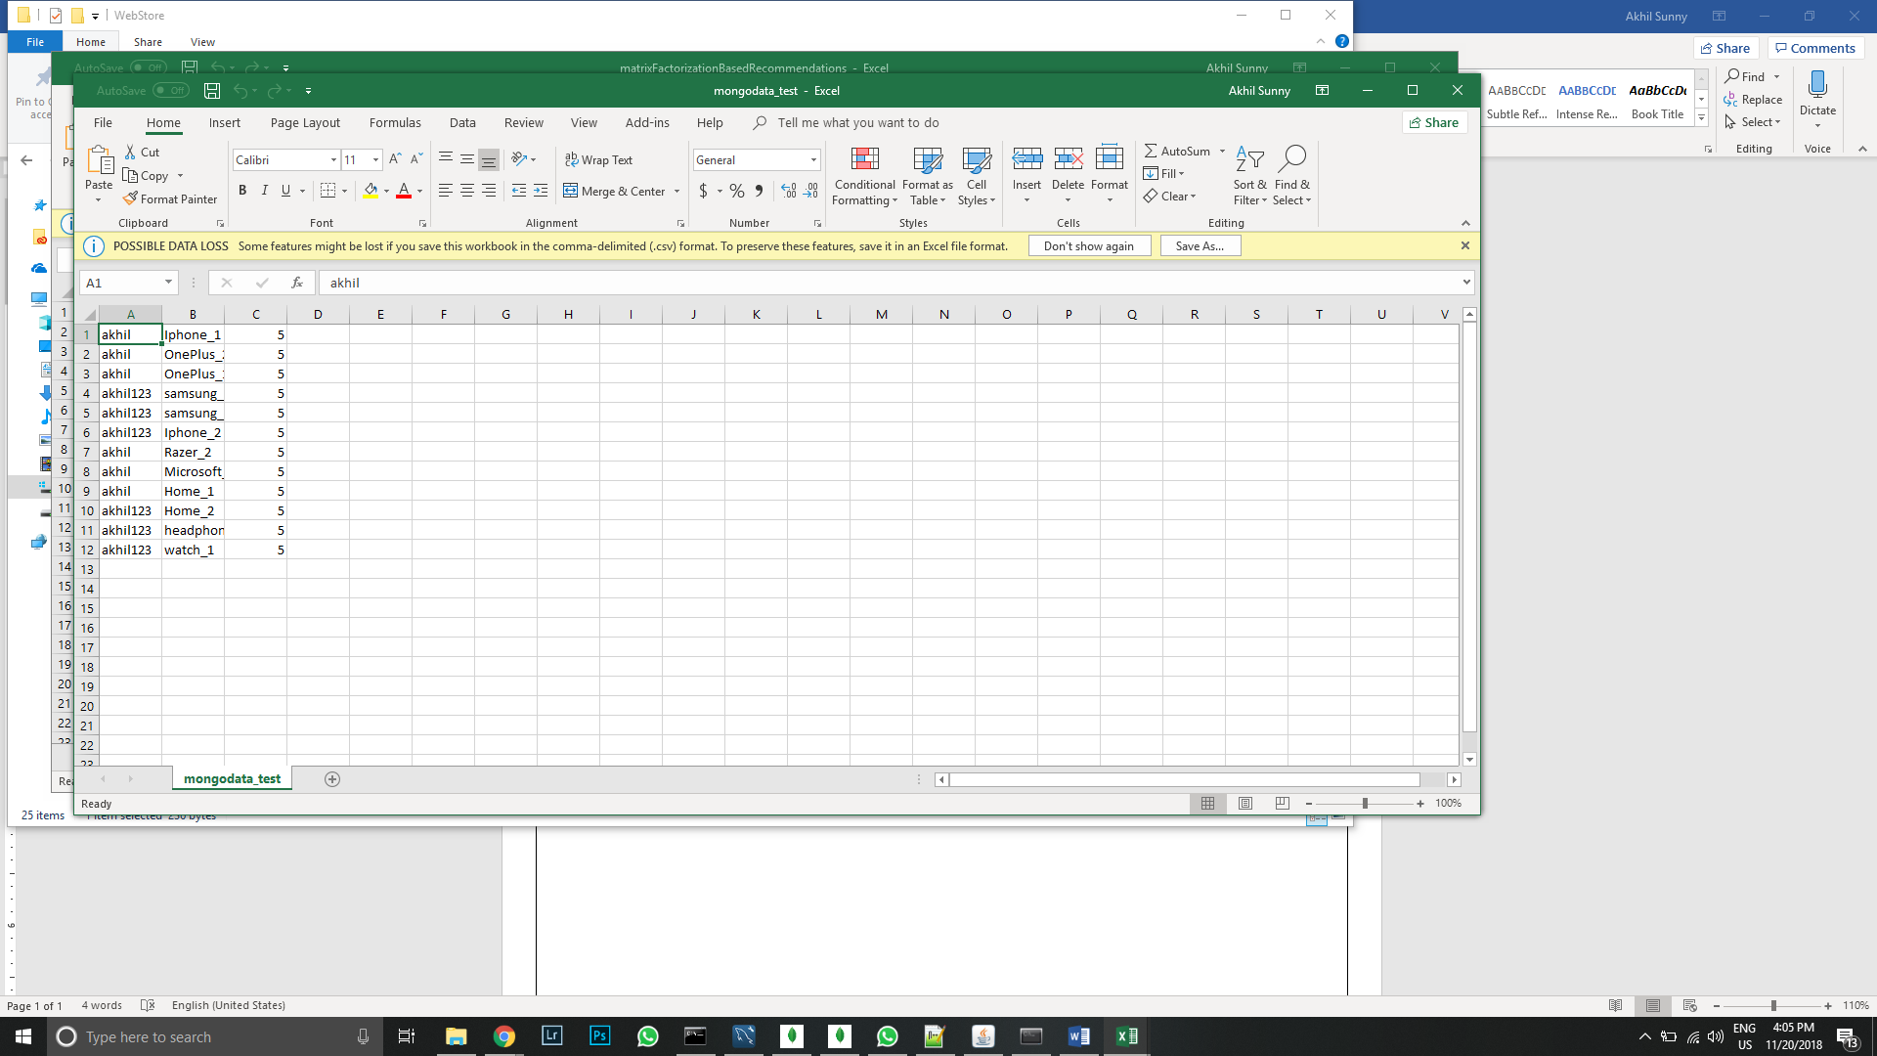

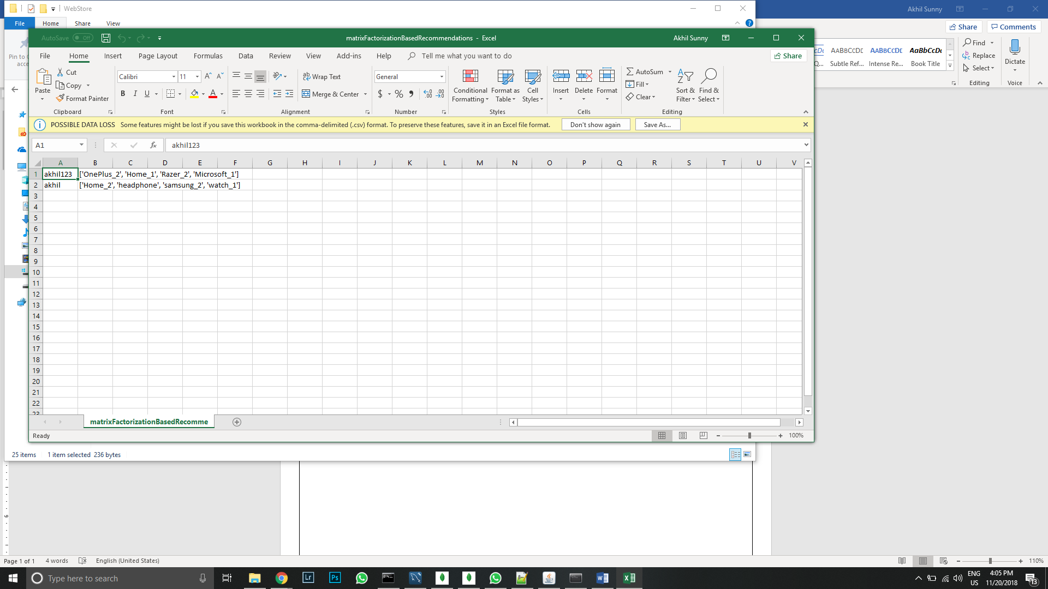

Upon selecting a particular product now

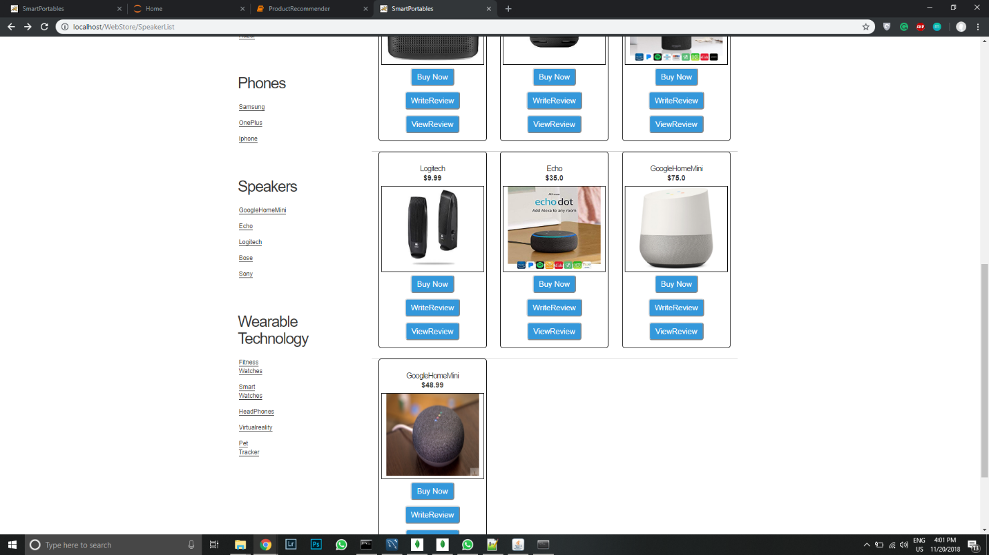

We would get all the four recommendations shown in output file with the help of carousel

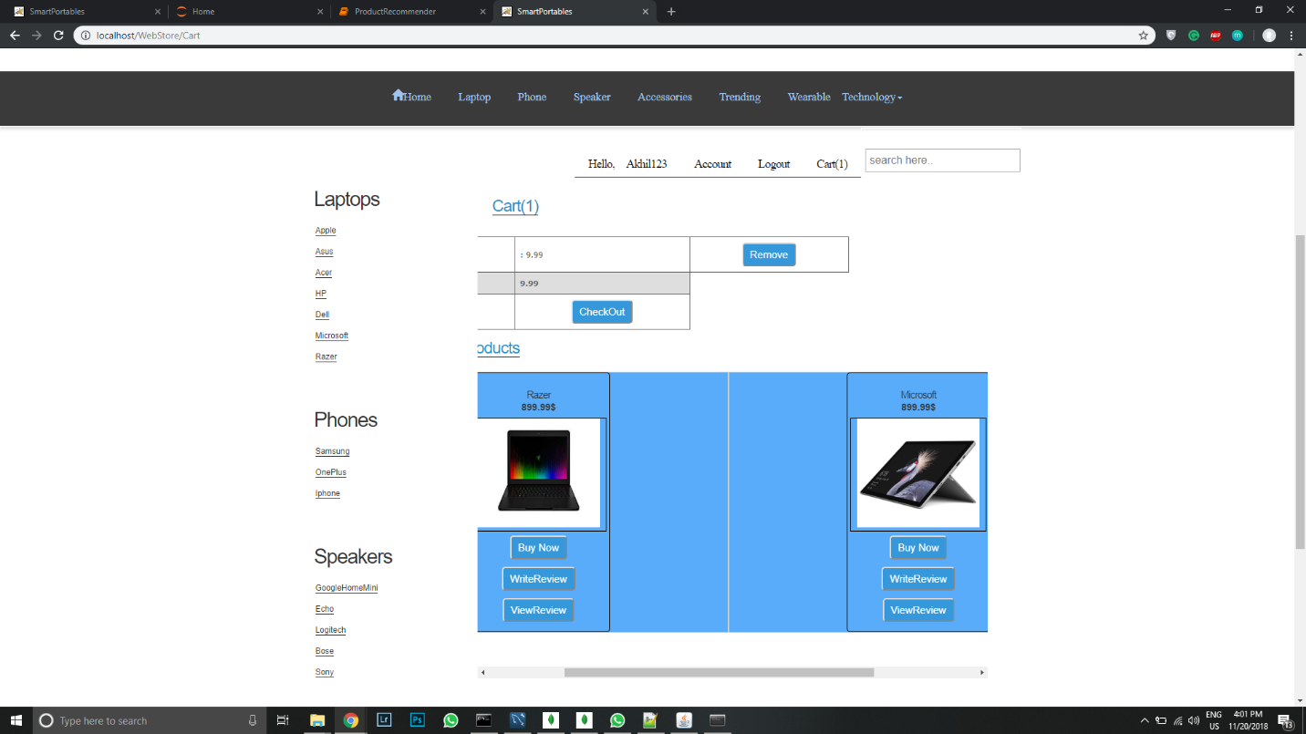

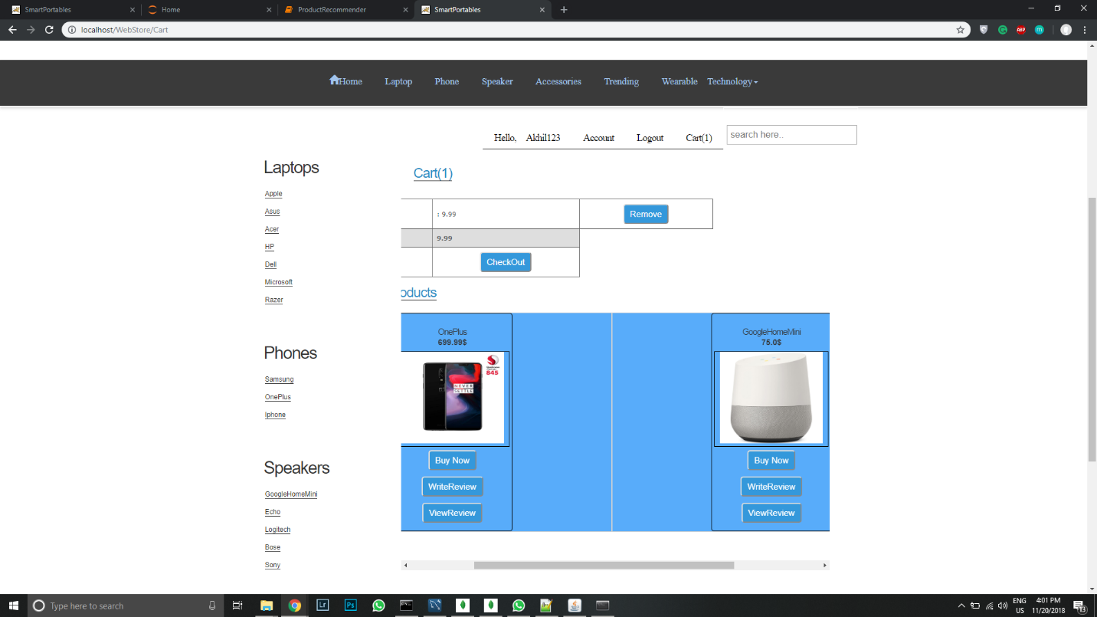

We could add them to cart and click check out.

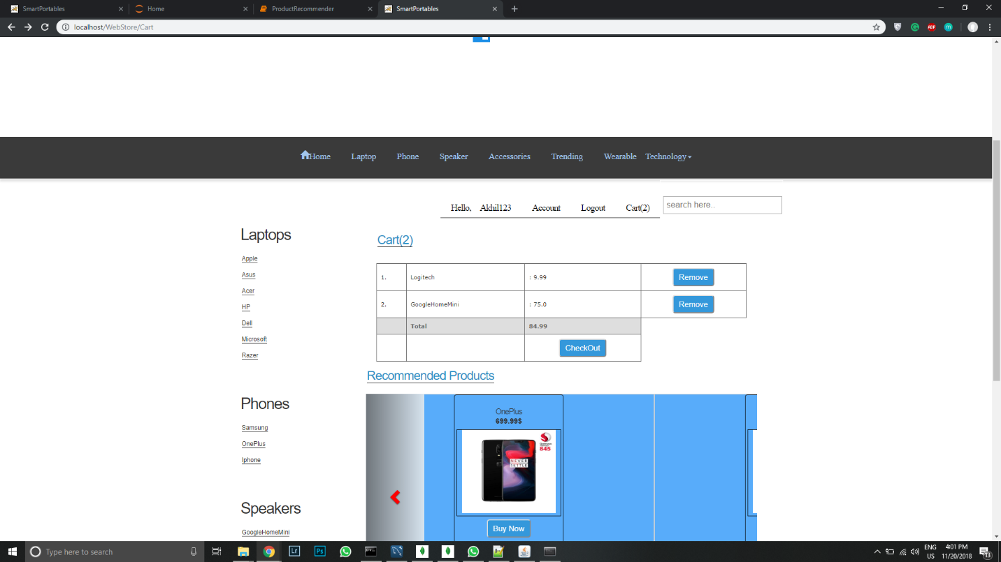

Rest of all works as usual. Thanks!